4
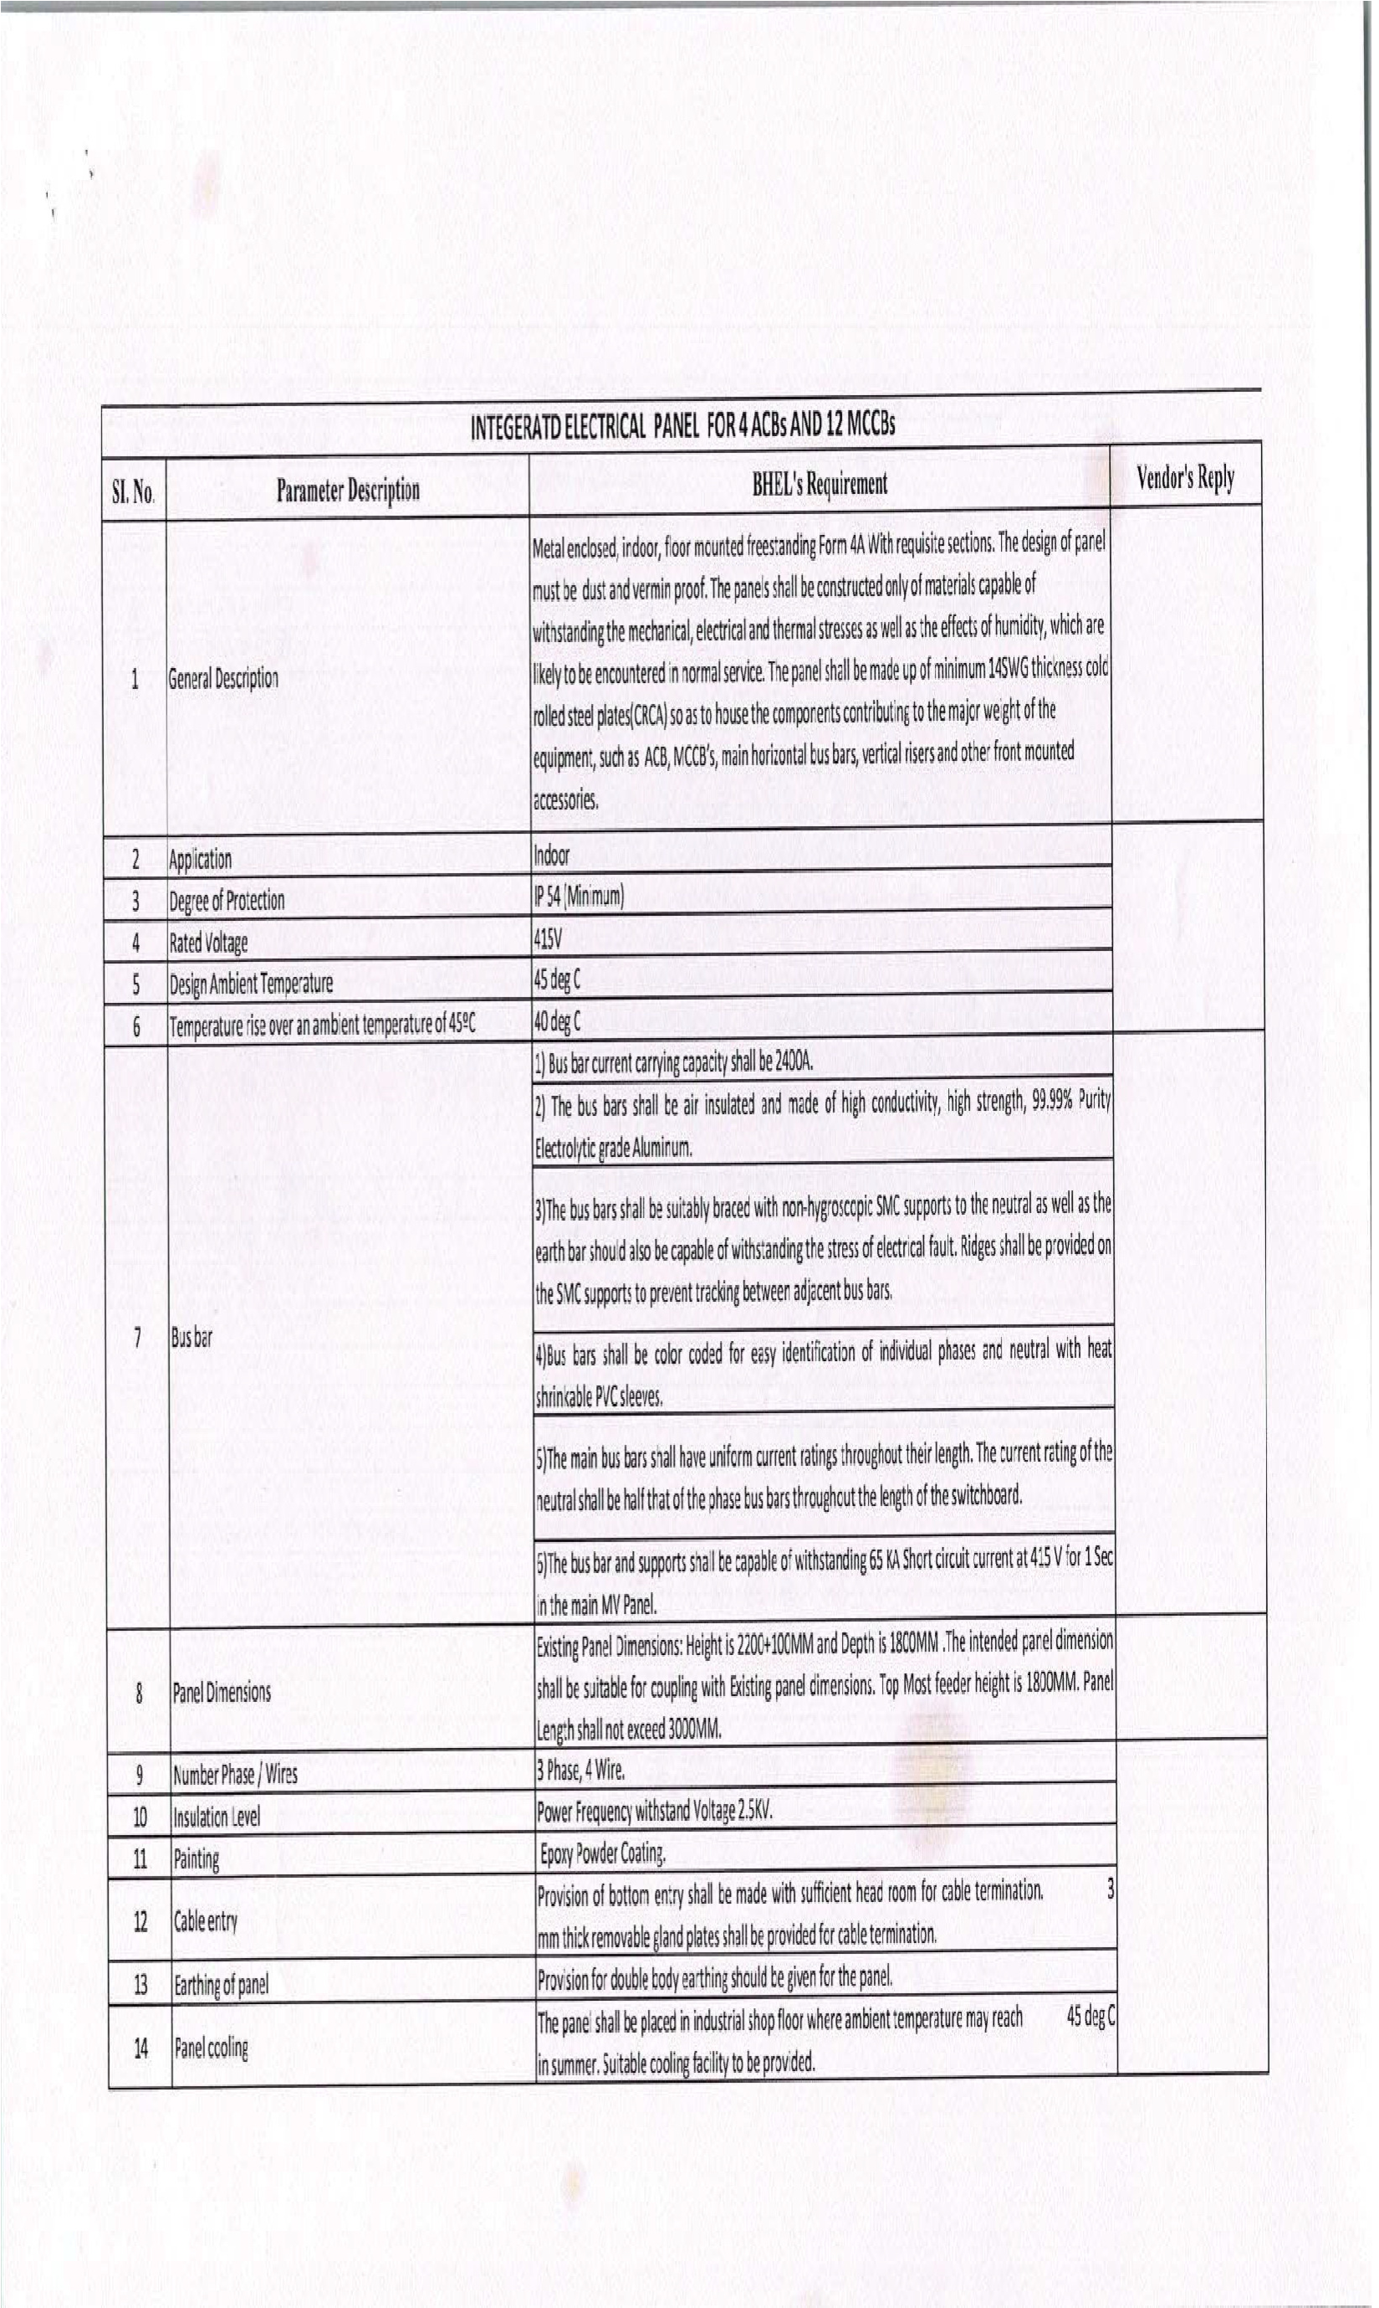
5
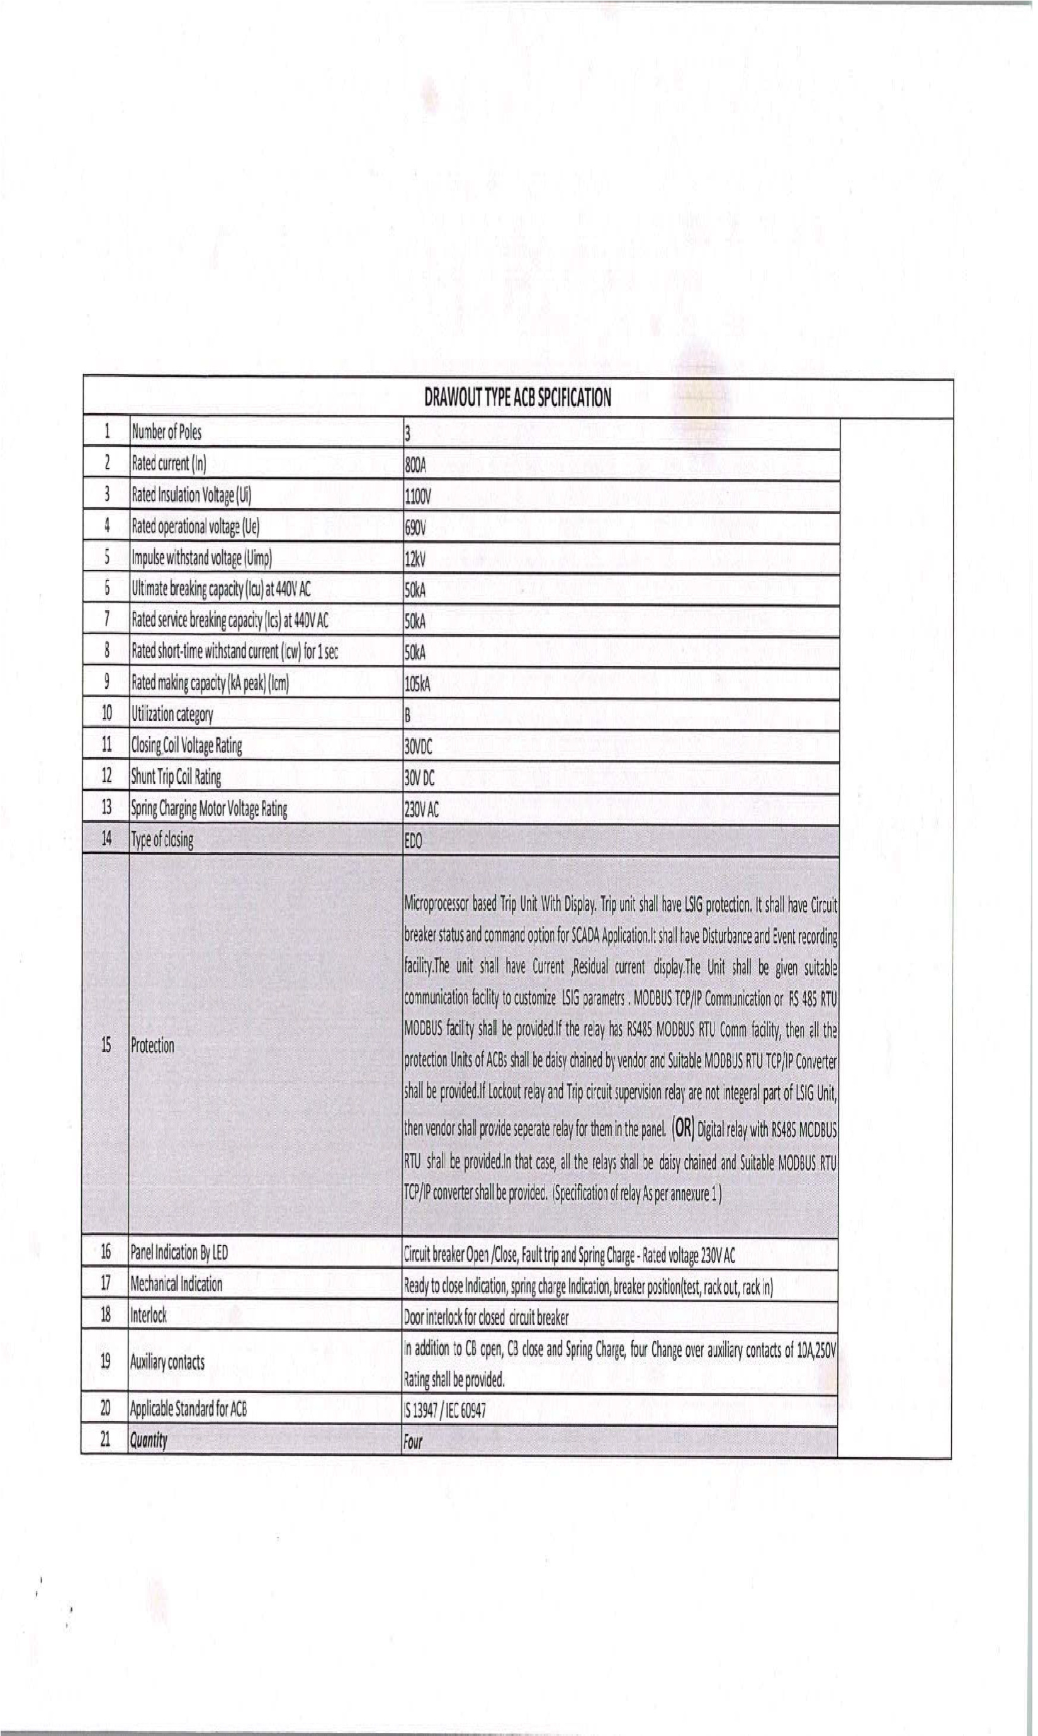
6
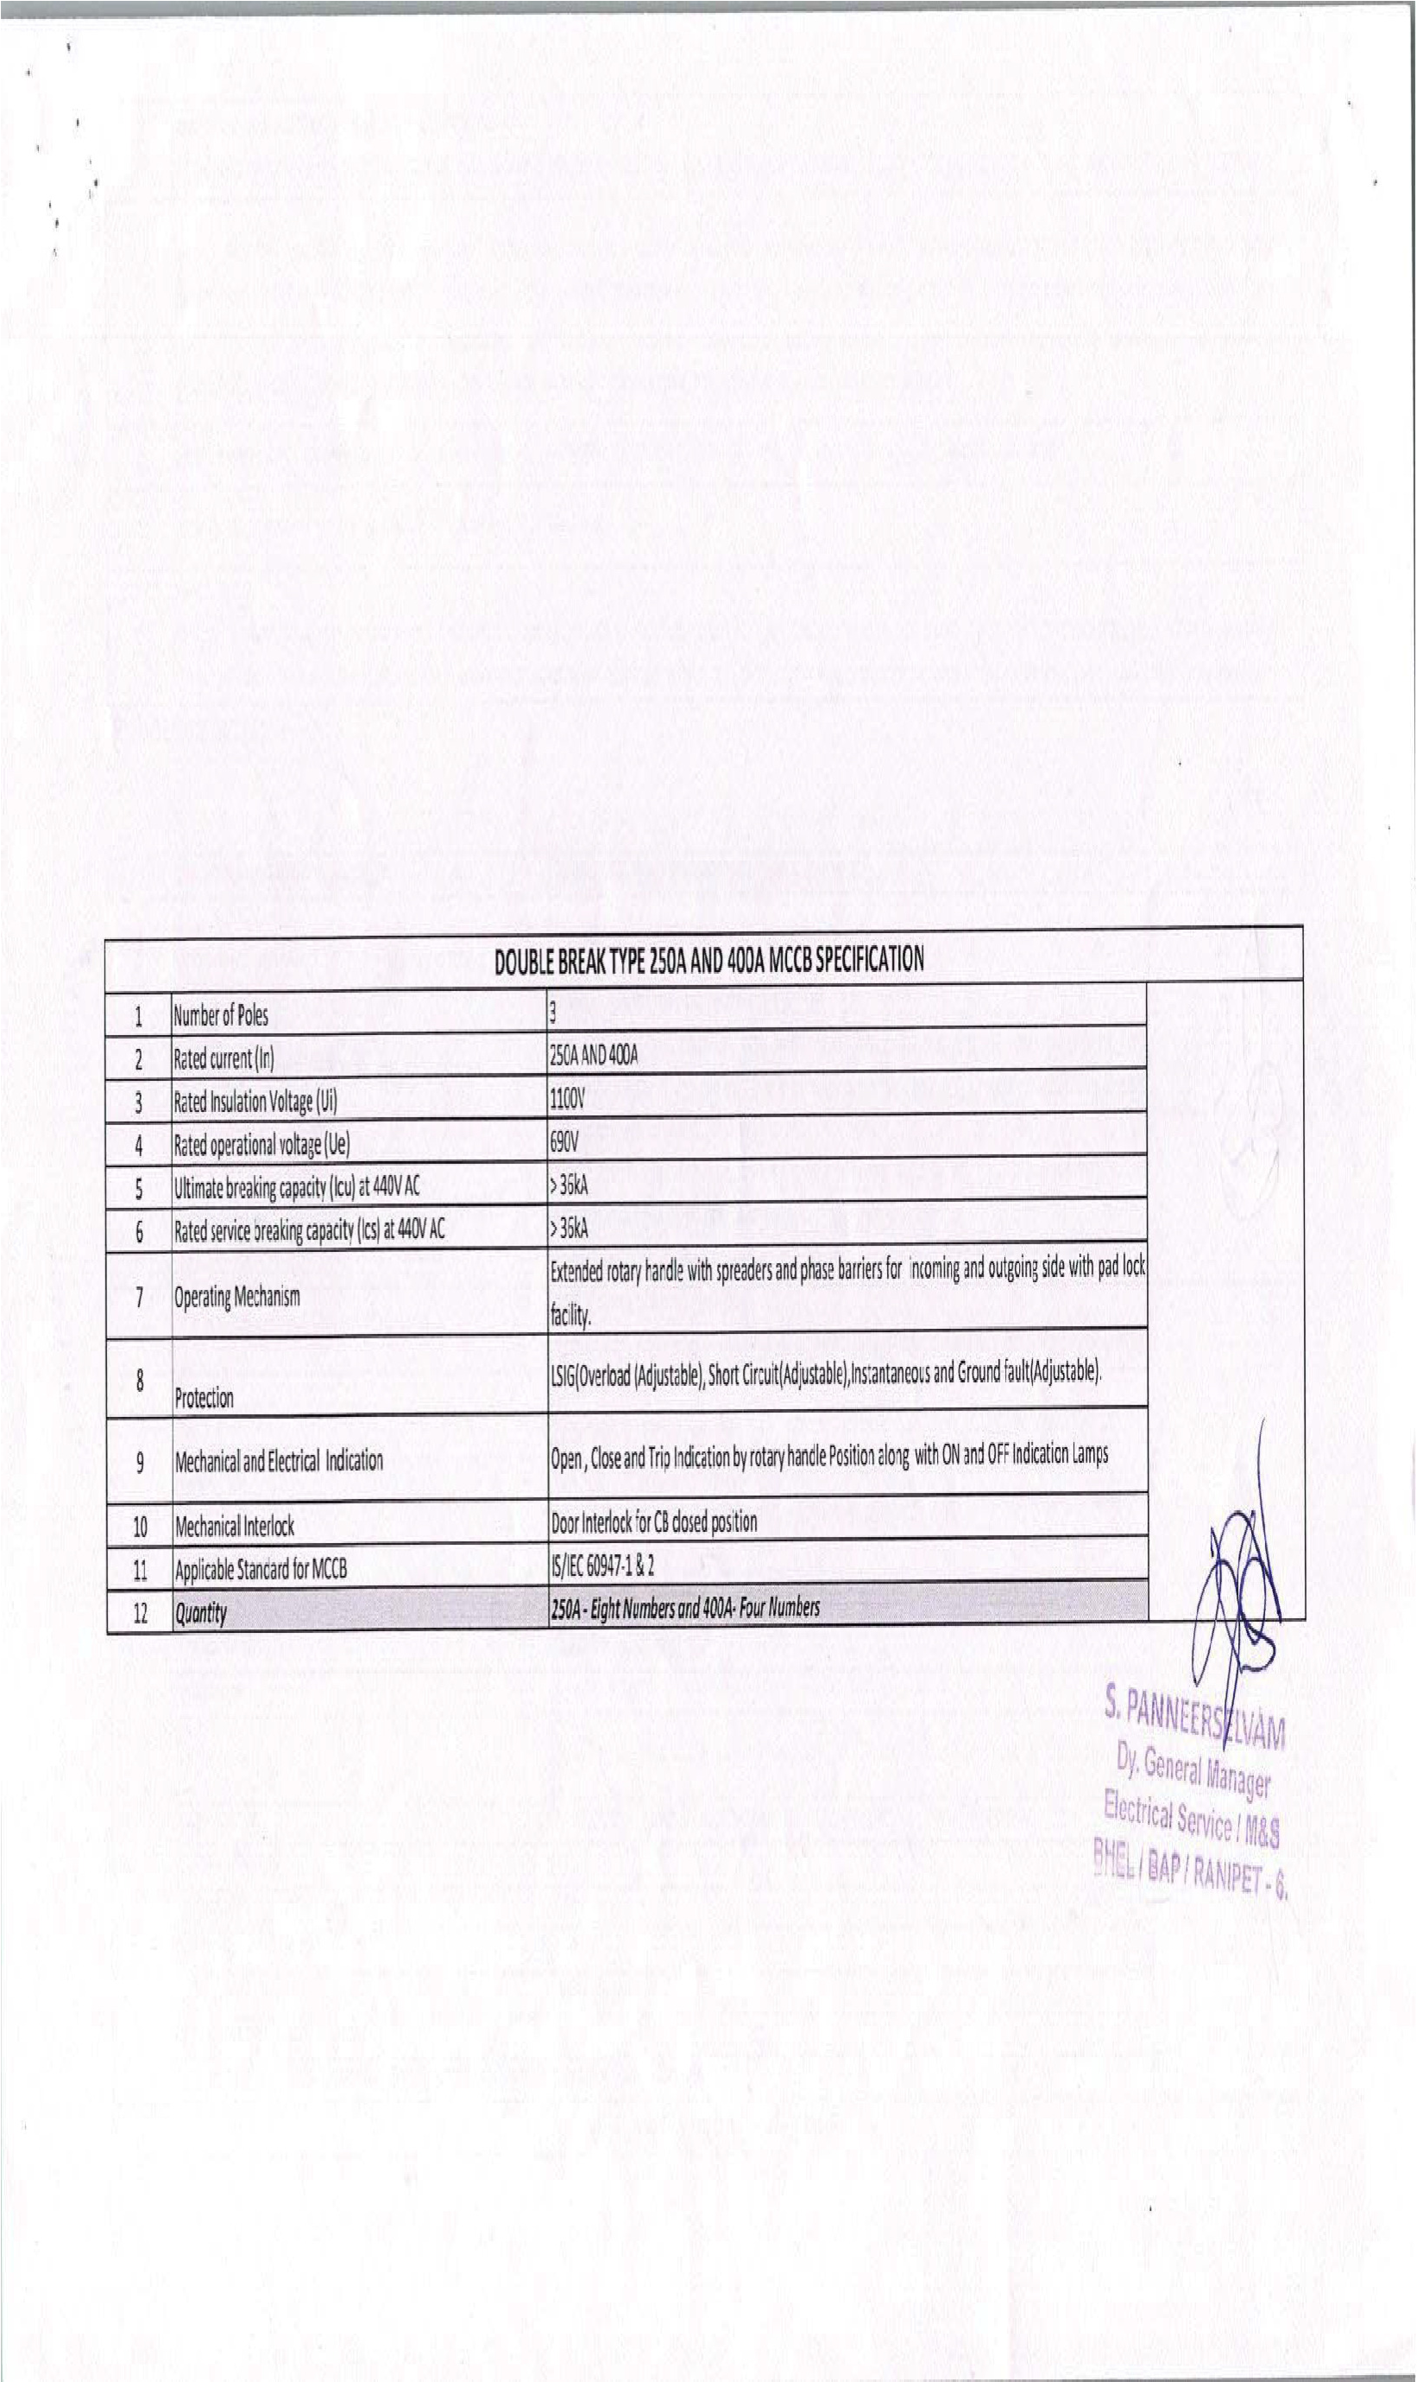
7
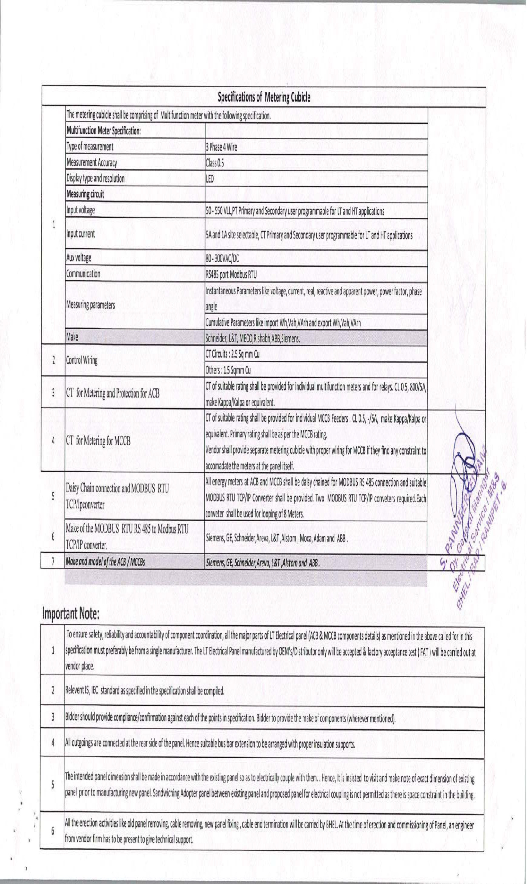
8
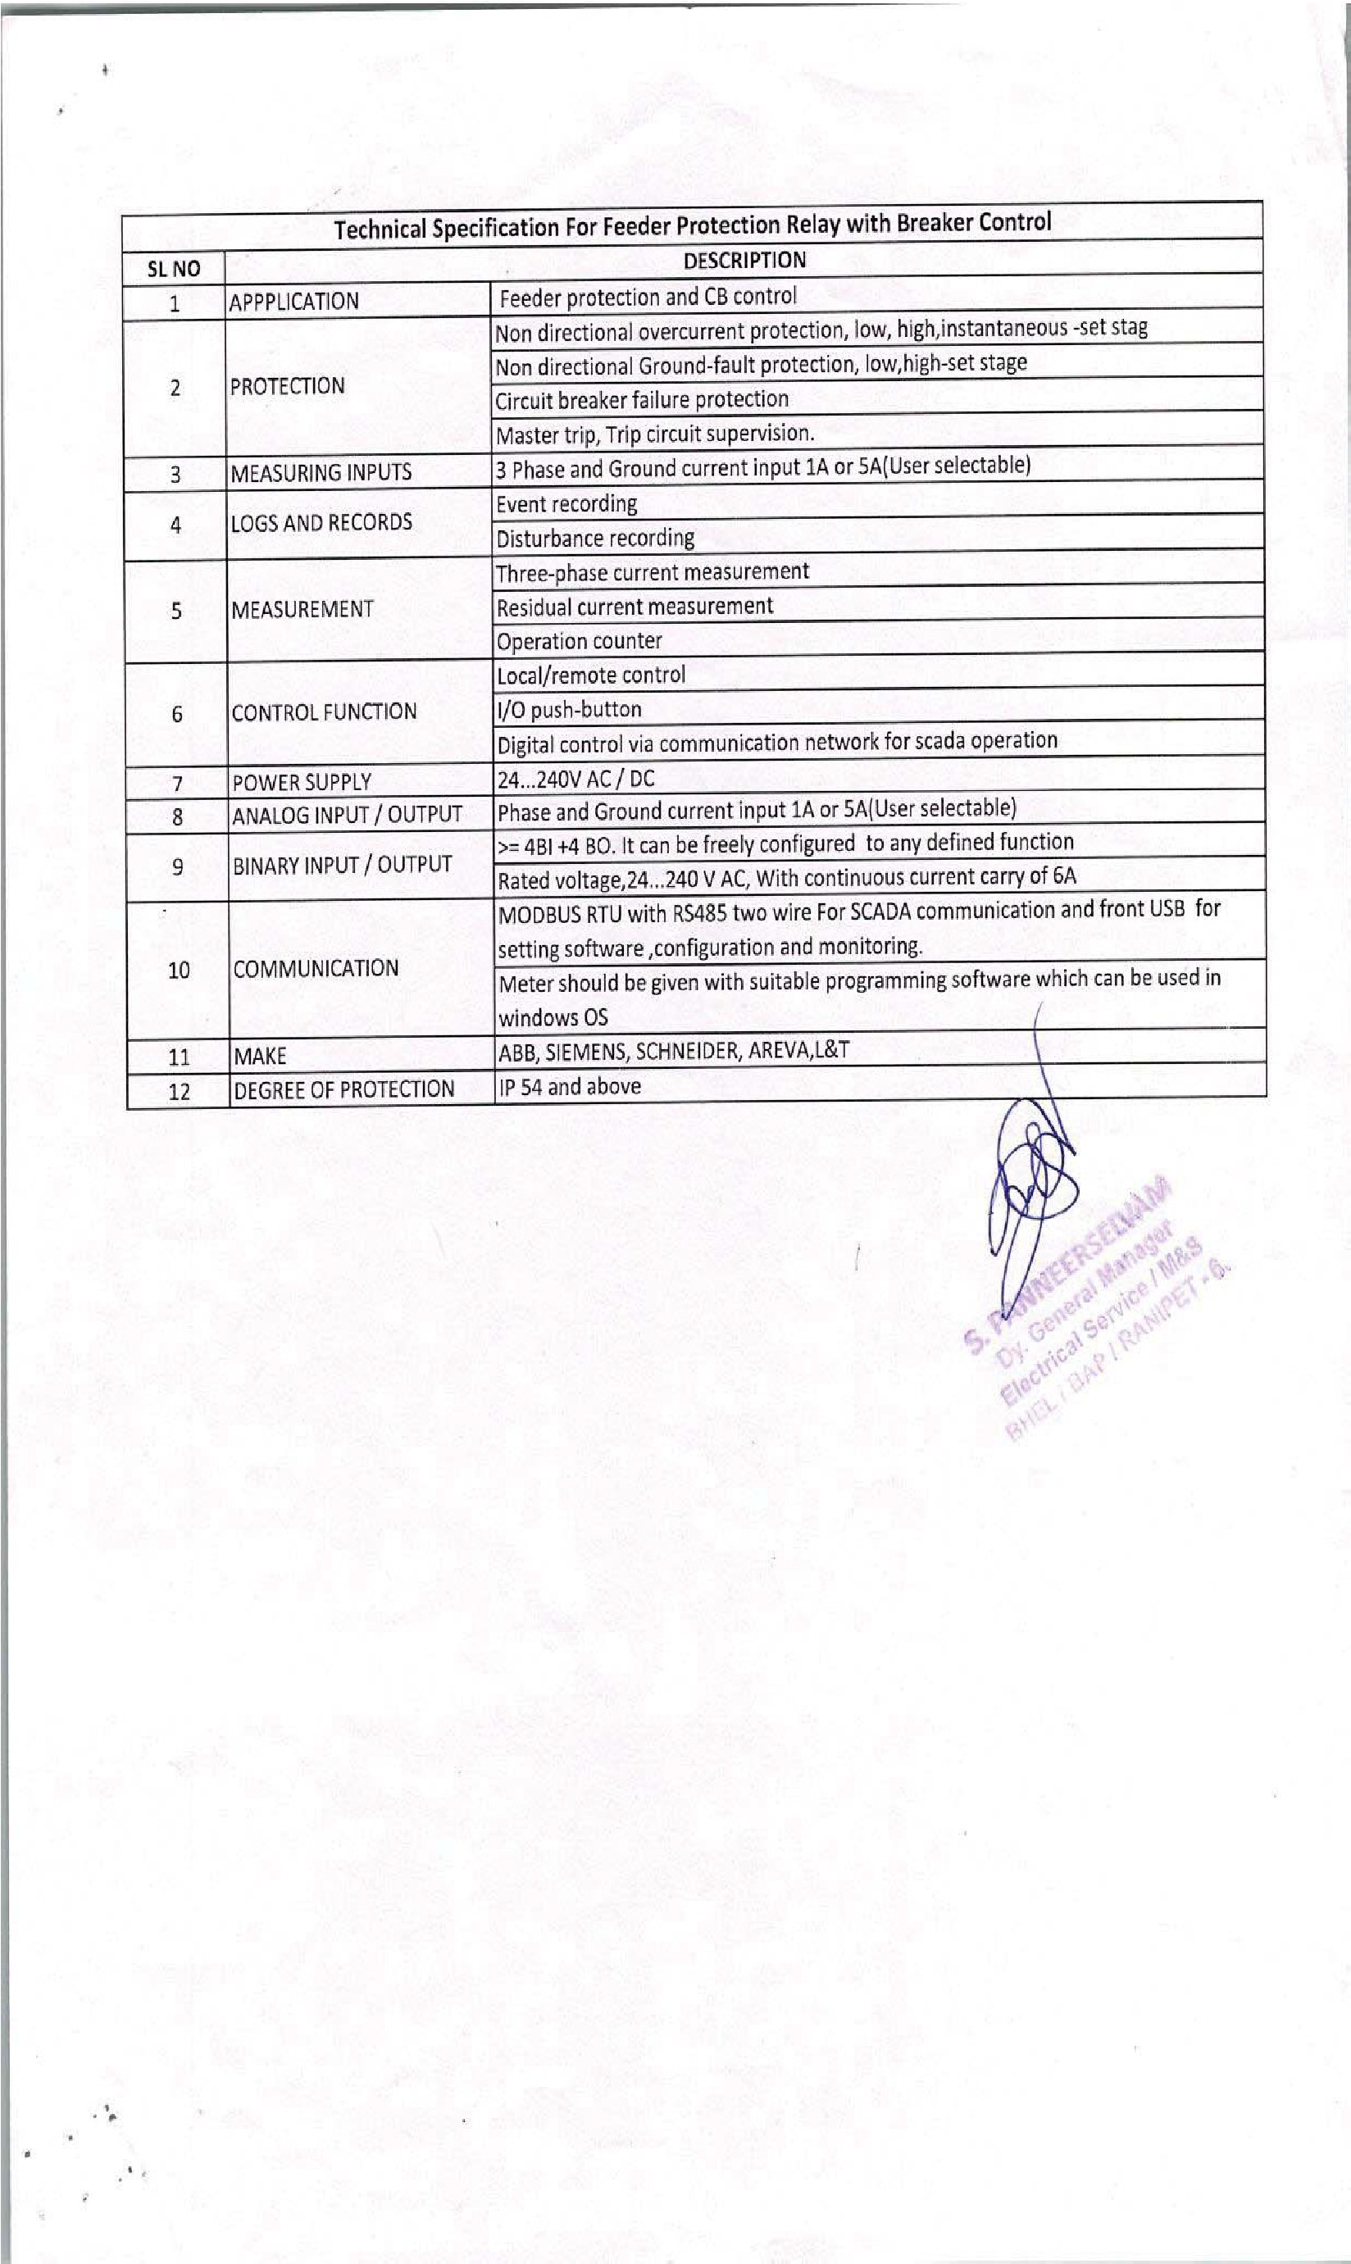
9
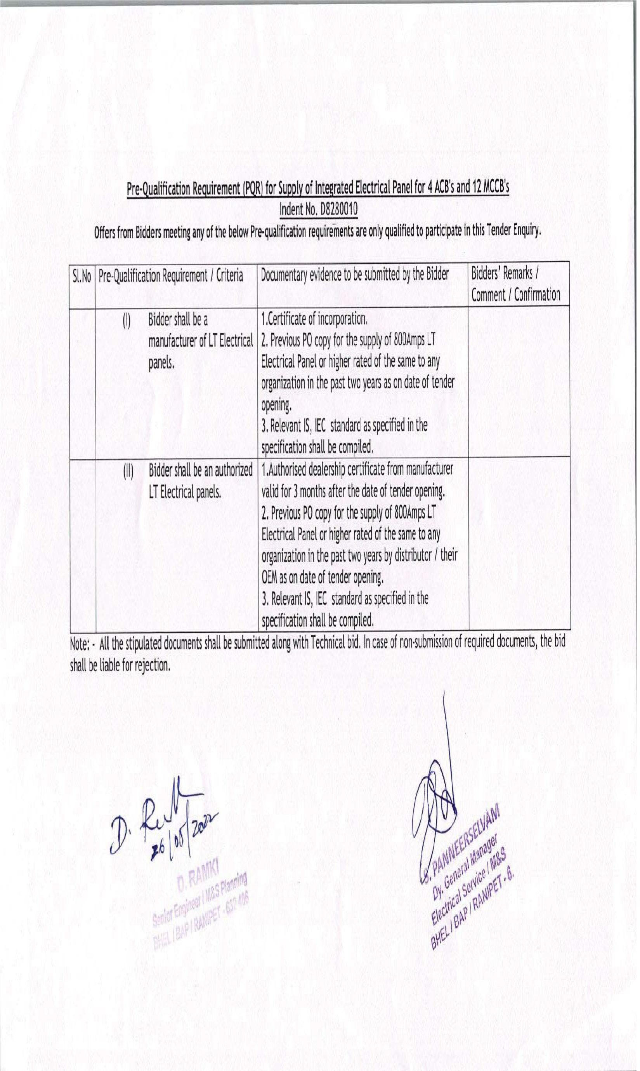

- Bid Price: The Bidder has to quote the Landed Price inclusive of Packing & Forwarding charges, all the routine & type tests as per tender scope, taxes, duties, freight and insurance etc. as specified in tender document.
- Apply/Select for Make in India Class-1 supplier if eligible.
- Apply/ select for MSE if eligible.
- Each time create a new catalogue for a new tender. Do not use old catalogue in new tender.
- Always put description in catalogue as per BHEL Tender description.
- Bidder fulfilling the PQR criteria shall only qualify for this bid.
- Bidder should upload PQR and technical specification after confirmation with seal &sign.
- GST invoice: PO No., PO Description, Material code in GST invoice shall be as per BHEL Purchase order, which will be released immediately after placing GeM contract. The GST invoice in hard copy or digitally signed shall only be accepted for payment by BHEL.

Payment term will be as follows-
For MSE Vendors – within 45 days of issue of consignee receipt –cum-acceptance certificate(CRAC).
For Medium category Vendors- within 60 days of issue of consignee receipt –cumacceptance certificate (CRAC).
For Non-MSE Vendors – within 90 days of issue of consignee receipt –cumacceptance certificate (CRAC).

